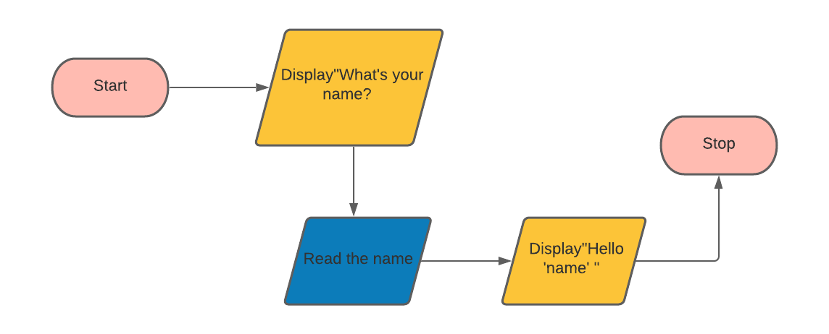

D1: Start

D2: Print”What’s your name”

D3: Read name

D4: Print”Hello ‘name’ “

D5: Stop